Lab 9: Tornadoes

Background:
For this lab, you will determine the strength of different categories of tornadoes using the Enhanced Fujitia (EF) scale.

Use this site:
http://www.spc.noaa.gov/efscale/ef-scale.html

Read the lab manual to learn how to assess the damage of a tornado.

Case Study
You will be assessing 2 tornadoes!!! (The lab manual only says to do one; this is incorrect!)

For each tornado, there are 3 pictures of the damage done. For each picture, you will fill out a “Tornado assessment.” You will do each case study individually using the Tornado Assessment forms (handed out).

Question 1:
There is no page 8.

For location number, write tornado number/brief description of the picture so I know which one you’re writing about.

Do not write anything for time of day.

Using the websites above, write the damage indicator(s), degree of damage, and expected wind speed in the space provided.

Next, write down the assessed wind speed and EF rating for each assessment based on the information you have found.

Tornado 1:

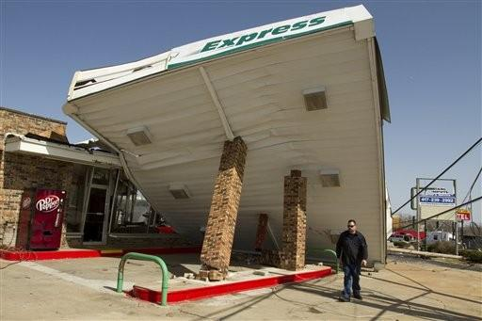

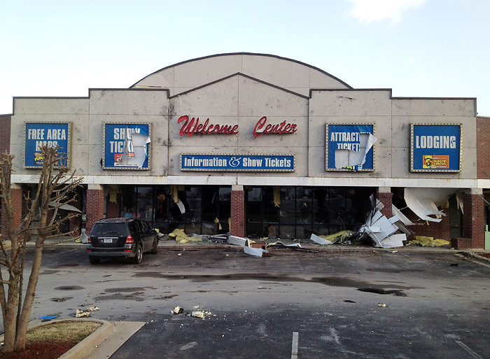

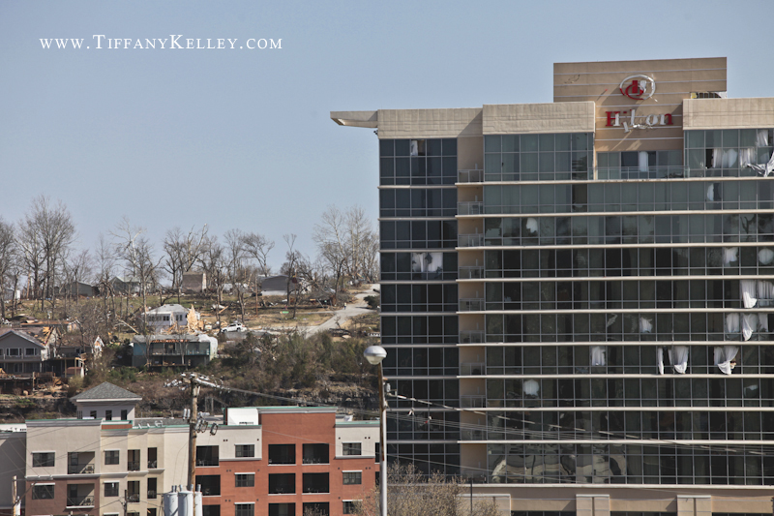

Tornado 2:

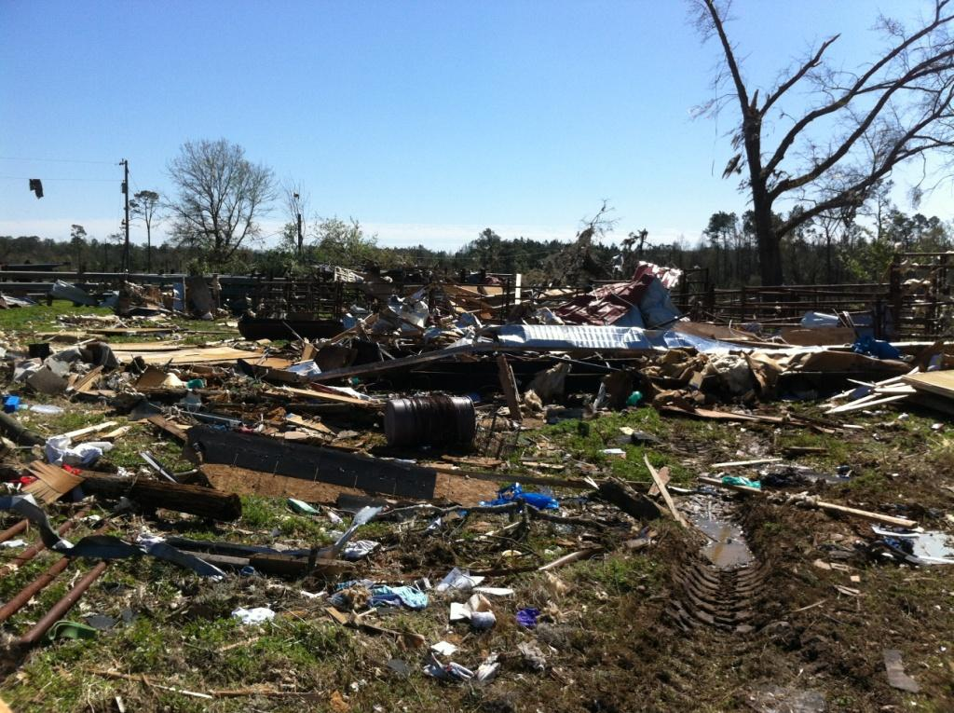

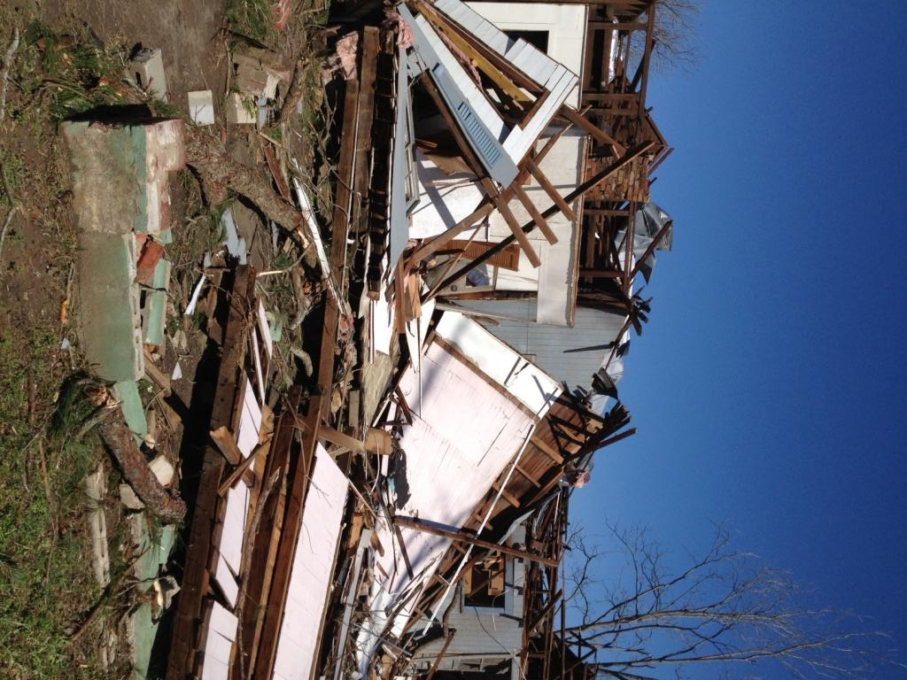

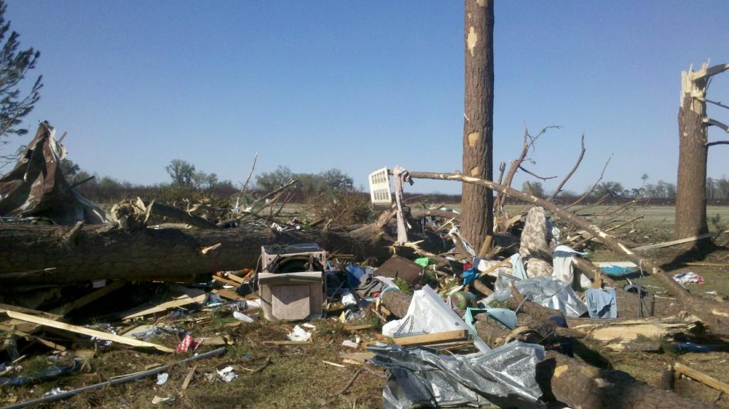

After you complete Question 1, form a group of 2-3 people. Scroll to the next page.

Question 2:
“Your EF Rating” refers to what you put as your rating, while the groups’ consensus rating is what you agree on as a group. Do this for each picture. Be sure to draw a dividing line in the table to differentiate between Tornado 1 and Tornado 2.

Questions 3 and 4:
Based on all of the photos for each tornado, what does your group think the overall EF rating is? Overall wind speed? Do this for each tornado (just draw a slash in the blank space to differentiate between tornado 1 and 2.

Answer Questions 6-8 individually.

